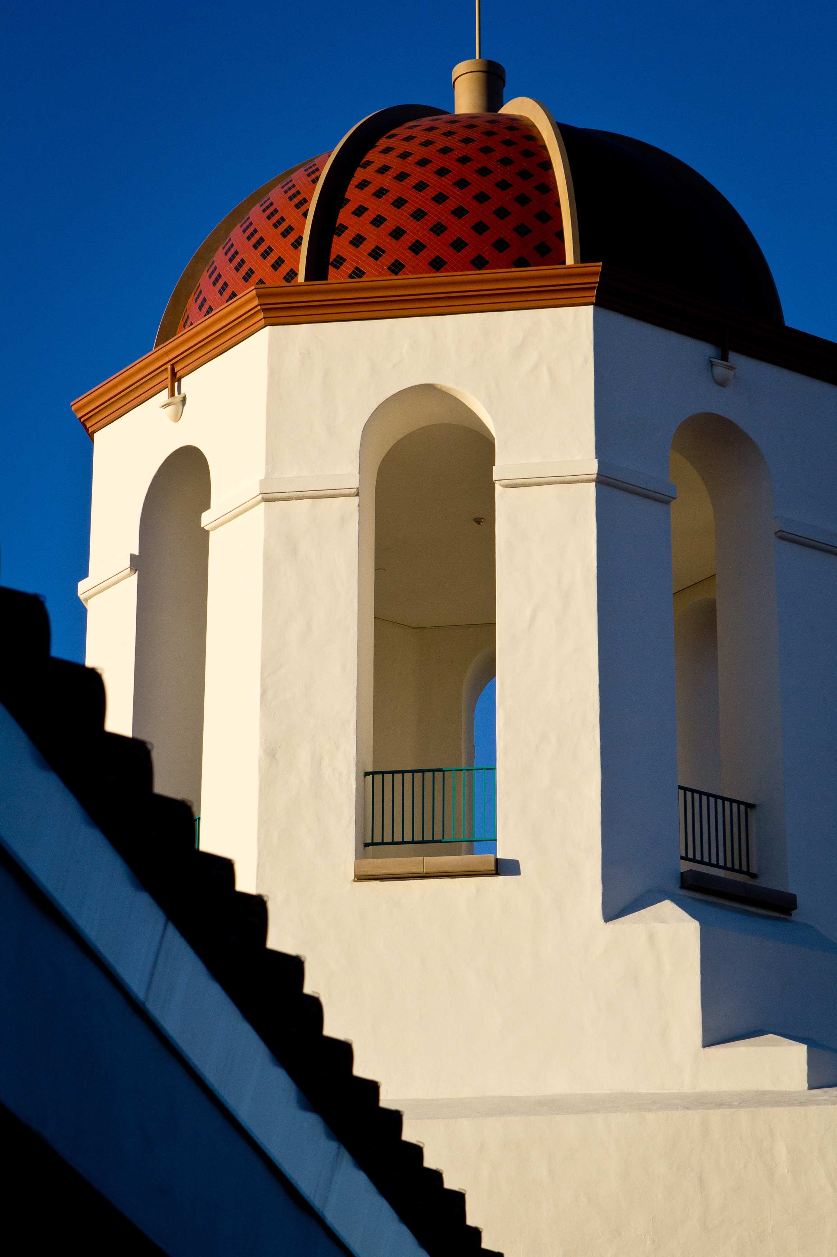  Conrad Prebys Aztec Student Union | Campus Safety Plan  2018

Availability, Location and Methods to Summon Law Enforcement Assistance
The San Diego State University (SDSU) Police Department is located at the corner of 55th Street and Remington Rd. on the San Diego State University campus and provides police services 24-hours a day to our community. Police dispatchers can be reached directly, 24-hours a day, by phone at 619-594-1991. The peace officers of SDSU have state-wide police authority and jurisdiction per Penal Code 830.2 and Education Code 89560, and are vested with law enforcement powers and responsibilities identical to the local police or sheriff departments in your home town.
Crime Reporting
The entire campus community is strongly encouraged to report any and all known or suspected incidents of criminal activity on campus to the University Police Department as soon as possible. When calling SDSU Police, always:
- Give your name, telephone number and location.
- Clear and accurate information.
- Suspect and vehicle description, and direction of travel.
- Do not hang up! Follow the directions of the dispatcher.
Telephone contact:
- Emergency: 9-1-1
- SDSU Police, non-emergency (619) 594-1991 (from campus phone dial 4-1991)
- Campus emergency duress phones (Blue Light Phones), will put you in direct contact with a dispatcher
To report a crime or other emergency occurring in the community surrounding SDSU, contact the San Diego Police Department by dialing 9-1-1 or (619) 531-2000, for non-emergencies.
Special Safeguards for Facilities or Activities
Campus facilities are provided primarily for the educational needs of enrolled students, research activities of faculty and business needs of staff members. Use of University Facilities is governed by the SDSU Buildings and Grounds Policy. Persons without a lawful purpose on campus may be removed per California Penal Code Section 626.6. Access to campus residence halls and apartments is by card access or key and is restricted to residents and registered guests. Access is regulated by University Housing.
Security phones/intercoms are located at the entrances of residential buildings and desk assistants are located in the lobby to assist visitors in contacting residents. Students who have a room or apartment doors open to the public are encouraged to keeps doors closed and locked at all times.
Special Event Safety Planning
Preparation for large events on campus involve the creation of Incident Action Plans according to the Standardized Emergency Management System and in collaboration with mutual aid agencies and contracted safety personnel.
New Student Orientations
University Police personnel provide personal safety tips and emergency contact information to new students on a regular basis. Students are informed of policies, voluntary confidential crime reporting and safety programs.
New Employee Orientations
Throughout the year University Police personnel present safety policies and procedures to new employees, in cooperation with Human Resources, Emergency Services and Environmental Health and Safety. Employees are informed of injury and illness prevention, workplace violence, safety programs and voluntary confidential crime reporting procedures.
Actions Taken in the Last 18 Months to Increase Safety:
- Hired 3 police officers and 4 police dispatchers.
- Began construction on a substation on the east side of campus.
- Implemented threat assessment team.
Changes in Safety Precautions Expected to Occur in the Next 24 Months:
- Add one police lieutenant and two police officers.
- Expand Community Service Officer safety escort services.
- Begin re-evaluation of aging “blue light” duress phones for possible replacement.
San Diego State University Statistical Report, 2016
The report is a separate and distinct report from the Annual Security Report required under the Jeanne Clery Disclosure of Campus Security Policy and Campus Crime Statistics Act (the Clery Act). The report can be found at
The statistics were compiled using the FBI Uniform Crime Reporting program definitions, occurring on campus, and in compliance with California State Education Code, Chapter 16, of the Donahue Higher Education Act, Section 67380.
2016 Statistics (California Education Code) 67380(a)(1)(A))
Occurrences and/or arrests for: | On Campus
Part 1 Violent Crimes | 10
Hate Crimes | 3
Noncriminal Acts of Hate Violence | 0
Theft | 496
Destruction of Property | 84
Illegal Drugs | 77
Alcohol Intoxication | 60

Occurrences and/or arrests for: | Systemwide
Hate Crimes | 16
Noncriminal Acts of Hate Violence | 1

